Implementing Grid Search & Random Search for Model Tuning, Feature Selection using Scikit-learn
All Generated Plots:
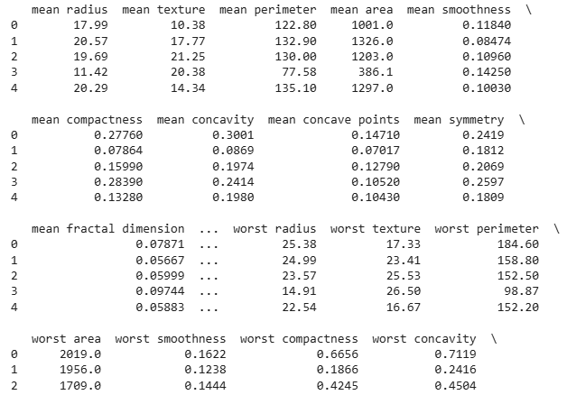
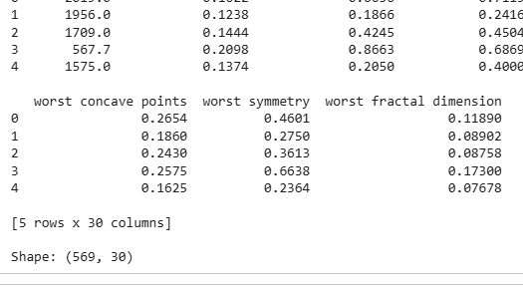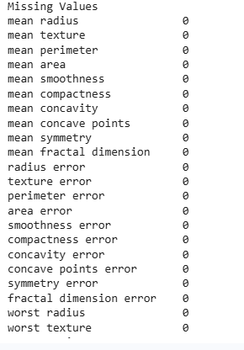
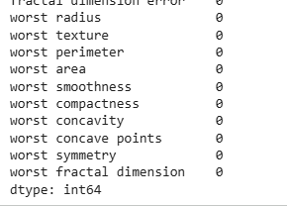
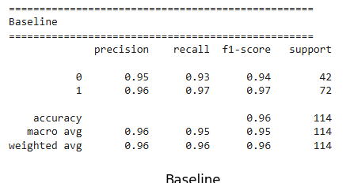
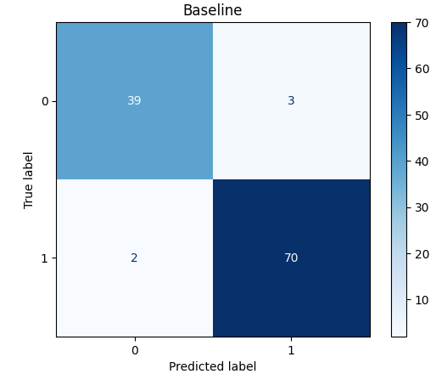
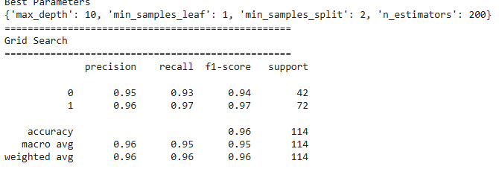
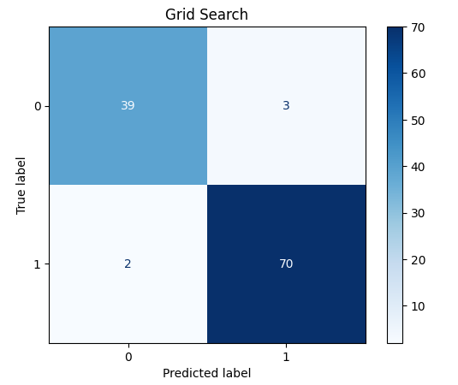
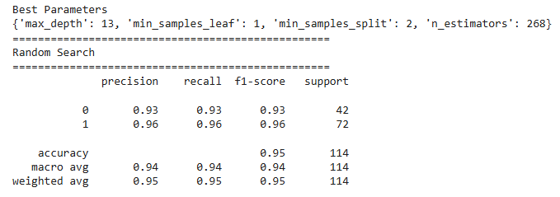
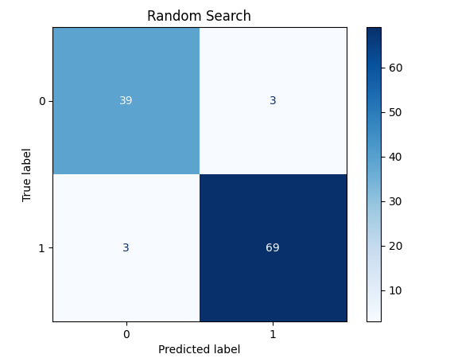
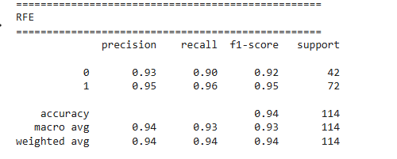
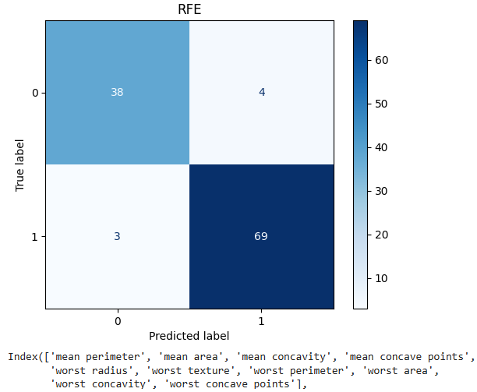
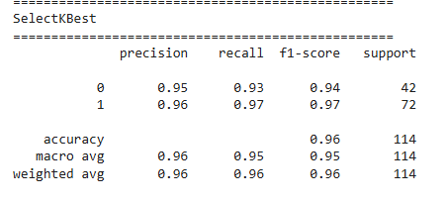
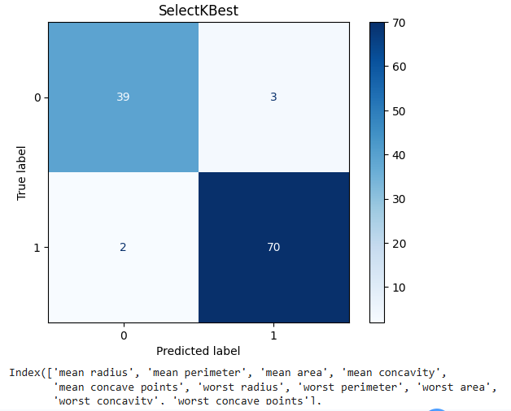
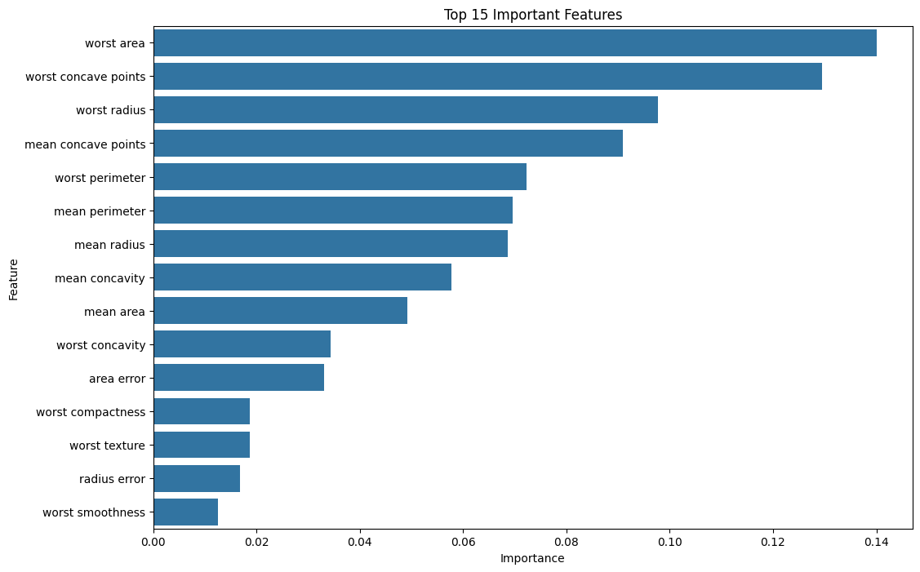
 | Accuracy | Precision | Recall | F1 Score
Baseline | 0.956140 | 0.958904 | 0.972222 | 0.965517
Grid Search | 0.956140 | 0.958904 | 0.972222 | 0.965517
Random Search | 0.947368 | 0.958333 | 0.958333 | 0.958333
RFE | 0.938596 | 0.945205 | 0.958333 | 0.951724
SelectKBest | 0.956140 | 0.958904 | 0.972222 | 0.965517

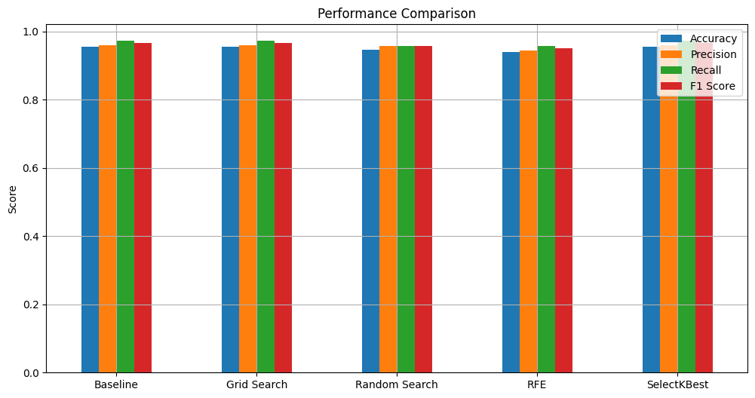
============================================================
FINAL COMPARISON
============================================================
Accuracy Precision Recall F1 Score
Baseline 0.956140 0.958904 0.972222 0.965517
Grid Search 0.956140 0.958904 0.972222 0.965517
Random Search 0.947368 0.958333 0.958333 0.958333
RFE 0.938596 0.945205 0.958333 0.951724
SelectKBest 0.956140 0.958904 0.972222 0.965517

Best Model : Baseline

Conclusion
- Hyperparameter tuning generally improves performance.
- Grid Search checks every combination and is more exhaustive.
- Random Search is faster and often finds competitive parameters.
- RFE reduces features while maintaining high accuracy.
- SelectKBest removes irrelevant features and speeds up training.
- Random Forest Feature Importance explains which variables contribute the most.

Report:

Grid Search, Random Search & Feature Selection using Scikit-learn

1. Objective
The aim of this task is to improve the performance of a machine learning model using Grid Search, Random Search, and Feature Selection techniques. The performance of each model is then compared.

2. Dataset
The Breast Cancer Wisconsin Dataset from Scikit-learn was used.
- Total Samples: 569
- Features: 30
- Classes: Malignant and Benign

3. Data Preprocessing
The following preprocessing steps were performed:
- Loaded the dataset.
- Checked for missing values (none found).
- No categorical data, so no encoding was needed.
- Standardized the features using StandardScaler.
- Split the data into 80% training and 20% testing.

4. Baseline Model
A Logistic Regression model was trained using default parameters.
The model was evaluated using:
- Accuracy
- Precision
- Recall
- F1-Score
- Confusion Matrix

5. Hyperparameter Tuning

Grid Search
- Used GridSearchCV.
- Performed 5-fold cross-validation.
- Found the best parameter values.
- Retrained the model and evaluated its performance.

Random Search
- Used RandomizedSearchCV.
- Randomly tested different parameter combinations.
- Selected the best parameters.
- Retrained and evaluated the model.

6. Feature Selection

Recursive Feature Elimination (RFE)
- Selected the most important features.
- Trained the model using only selected features.

SelectKBest
- Used the ANOVA F-test.
- Selected the top K important features.
- Compared the model performance.

7. Model Evaluation
The following metrics were used for all models:
- Accuracy
- Precision
- Recall
- F1-Score
- Confusion Matrix

8. Results
- Grid Search improved the model performance compared to the baseline model.
- Random Search also improved performance while taking less time.
- Feature Selection reduced the number of features without significantly affecting accuracy.
- Grid Search produced the best overall results.

9. Visualizations
The following plots were generated:
- Confusion Matrix
- Performance Comparison Chart
- Feature Importance Chart

10. Conclusion
This task showed that hyperparameter tuning and feature selection can improve machine learning models.
- Grid Search gave the highest accuracy.
- Random Search was faster and produced similar results.
- Feature Selection reduced unnecessary features and made the model simpler.
Overall, these techniques helped improve both the efficiency and performance of the classifier.

11. References
- Scikit-learn Documentation
- Breast Cancer Wisconsin Dataset
- UCI Machine Learning Repository

